
ASSIGNMENT NO 2
231678_AROOBA

BSCS-4B
MAM SARA IBRAHIM
VISUAL PROGRAMMING

Employee Management System - Complete Report

Introduction
The Employee Management System is a Blazor-based web application that enables organizations to efficiently manage employee records. This system provides essential functionalities such as adding, editing, deleting, and listing employees. Additionally, it includes features for salary calculation and employee count tracking. The system is designed to be user-friendly and interactive.

Features
- Employee List - View and search employee records.
- Add/Edit Employee - Add new employees or modify existing ones.
- Delete Employee - Remove employees from the system.
- Salary Calculation - Compute net salary after deductions.
- Employee Counter - Track the total number of employees.
- Navigation System - Provides easy access to different modules of the system.

Technologies Used
- Blazor (Server-Side) - UI Framework for interactive web applications.
- C# - Backend logic and data processing.
- ASP.NET Core - Web framework for application hosting.
- Razor Components - Used for structuring pages.
- Bootstrap - Styling and responsive design.

Implementation Details

1. Home Page (Home.razor)
The home page provides an overview of the system's functionalities and navigation links.

2. Employee Model (Employee.cs)
Defines the properties of an employee such as Id, Name, Age, Department, and Salary.

3. Employee Service (EmployeeService.cs)
Handles operations such as:
- Retrieving all employees
- Searching employees
- Adding, updating, and deleting employee records
- Tracking the employee count

4. Employee Form (EmployeeForm.razor)
A form for adding and editing employee records. It validates user input and interacts with EmployeeService to store data.

5. Employee List (EmployeeList.razor)
Displays all employees in a table format. Users can:
- Search for employees by name or department.
- Edit employee records.
- Delete employees with a confirmation.

6. Salary Calculation (SalaryCalculation.razor & SalaryCalculationService.cs)
Calculates the net salary based on tax deductions and bonuses.

7. Employee Counter (Counter.razor)
Displays the total number of employees in the system.

8. Navigation (NavBar.razor)
Provides an interactive navigation menu for accessing different sections of the system.

9. Program Entry (Program.cs)
Configures and registers services, including EmployeeService and SalaryCalculationService.

Complete Source Code
HOME.RAZOR
@page "/"

<PageTitle>Home</PageTitle>

<h1>Welcome to the Employee Management System</h1>
<p>The Employee Management System is a user-friendly Blazor application designed to streamline employee record management. This system allows users to efficiently handle employee data, including adding, updating, and removing records, as well as calculating salaries.</p>

<h2>Features of the System</h2>
<ul>
<li><strong>Employee List:</strong> View a list of employees with their details.</li>
<li><strong>Add/Edit Employee:</strong> Add new employees or update existing records.</li>
<li><strong>Delete Employee:</strong> Remove employees with confirmation.</li>
<li><strong>Salary Calculation:</strong> Compute net salaries with deductions and allowances.</li>
<li><strong>Employee Counter:</strong> Track the total number of employees in the system.</li>
</ul>

<h2>Navigation</h2>
<p>Use the navigation links provided to explore different functionalities of the system:</p>
<ul>
<li><a href="/employee-list">Employee List</a></li>
<li><a href="/add-edit-employee">Add Employee</a></li>
<li><a href="/salary-calculation">Salary Calculator</a></li>
<li><a href="/counter">Employee Counter</a></li>
</ul>

<p>Get started by navigating through the system and managing employee records efficiently!</p>

EMPLOYEE.CS
public class Employee
{
public int Id { get; set; }
public string Name { get; set; } = string.Empty;
public int Age { get; set; }
public string Department { get; set; } = string.Empty;
public decimal Salary { get; set; }
}

EMPLOYEESERVICE.CS
using System.Collections.Generic;
using System.Linq;
using static EmployeeManagementSystem.Components.Pages.EmployeeForm;

public class EmployeeService
{
private List<Employee> Employees = new();
public int EmployeeCount { get; private set; } = 0;

public List<Employee> GetAllEmployees()
{
return Employees;
}

public int GetEmployeeCount()
{
return EmployeeCount;
}
public void AddEmployee(Employee employee)
{
employee.Id = Employees.Count + 1;
Employees.Add(employee);
EmployeeCount++;
}
public Employee GetEmployeeById(int id)
{
return Employees.FirstOrDefault(e => e.Id == id);
}

public void UpdateEmployee(Employee employee)
{
var existing = Employees.FirstOrDefault(e => e.Id == employee.Id);
if (existing != null)
{
existing.Name = employee.Name;
existing.Age = employee.Age;
existing.Department = employee.Department;
existing.Salary = employee.Salary;
}
}

public void DeleteEmployee(int id)
{
var employee = Employees.FirstOrDefault(e => e.Id == id);
if (employee != null)
{
Employees.Remove(employee);
EmployeeCount--;
}
}

public List<Employee> SearchEmployees(string searchTerm)
{
return Employees.Where(e => e.Name.Contains(searchTerm, System.StringComparison.OrdinalIgnoreCase) ||
e.Department.Contains(searchTerm, System.StringComparison.OrdinalIgnoreCase)).ToList();
}
}

EMPLOYEEFORM.RAZOR
@page "/add-edit-employee/{Id:int?}"
@inject NavigationManager Navigation
@inject EmployeeService EmployeeService
@rendermode InteractiveServer

<h3>@(Employee.Id == 0 ? "Add Employee" : "Edit Employee")</h3>

<EditForm Model="@Employee" OnValidSubmit="SaveEmployee">
<DataAnnotationsValidator />
<div>
<label>Name:</label>
<InputText @bind-Value="Employee.Name" required class="form-control" />
<ValidationMessage For="@(() => Employee.Name)" />
</div>

<div>
<label>Age:</label>
<InputNumber @bind-Value="Employee.Age" class="form-control" />
<ValidationMessage For="@(() => Employee.Age)" />
</div>

<div>
<label>Department:</label>
<InputText @bind-Value="Employee.Department" class="form-control" />
<ValidationMessage For="@(() => Employee.Department)" />
</div>

<div>
<label>Salary:</label>
<InputNumber @bind-Value="Employee.Salary" class="form-control" />
<ValidationMessage For="@(() => Employee.Salary)" />
</div>

<button type="submit" class="btn btn-primary">Save</button>
</EditForm>

@if (!string.IsNullOrEmpty(Message))
{
<p class="text-success">@Message</p>
}

@code {
[Parameter] public int? Id { get; set; } // ID parameter for editing
private Employee Employee { get; set; } = new Employee();
private string Message = string.Empty;

protected override void OnInitialized()
{
if (Id.HasValue)
{
// Fetch existing employee details for editing
var existingEmployee = EmployeeService.GetEmployeeById(Id.Value);
if (existingEmployee != null)
{
Employee = new Employee
{
Id = existingEmployee.Id,
Name = existingEmployee.Name,
Age = existingEmployee.Age,
Department = existingEmployee.Department,
Salary = existingEmployee.Salary
};
}
}
}

private async Task SaveEmployee()
{
if (Employee.Salary <= 0)
{
Message = "Salary must be a positive number!";
return;
}

if (Employee.Id == 0)
{
// Add new employee
EmployeeService.AddEmployee(Employee);
}
else
{
// Update existing employee
EmployeeService.UpdateEmployee(Employee);
}

Message = "Employee details saved successfully!";
Navigation.NavigateTo("/employee-list");
}
}

EMPLOYEELIST.RAZOR
@page "/employee-list"
@inject EmployeeService EmployeeService
@inject NavigationManager Navigation
@rendermode InteractiveServer

<h3>Employee List</h3>

<input type="text" @bind="SearchTerm" @oninput="SearchEmployees" placeholder="Search by name or department" class="form-control mb-2" />

<table class="table">
<thead>
<tr>
<th>Name</th>
<th>Age</th>
<th>Department</th>
<th>Salary</th>
<th>Actions</th>
</tr>
</thead>
<tbody>
@foreach (var emp in FilteredEmployees)
{
<tr>
<td>@emp.Name</td>
<td>@emp.Age</td>
<td>@emp.Department</td>
<td>@emp.Salary</td>
<td>
<button class="btn btn-warning" @onclick="() => EditEmployee(emp.Id)">Edit</button>
<button class="btn btn-danger ms-2" @onclick="() => DeleteEmployee(emp.Id)">Delete</button>
</td>
</tr>
}
</tbody>
</table>

<button class="btn btn-primary mt-3" @onclick="AddNewEmployee">Add New Employee</button>

@code {
private string SearchTerm = string.Empty;
private List<Employee> FilteredEmployees = new();

protected override void OnInitialized()
{
FilteredEmployees = EmployeeService.GetAllEmployees();
}

private void SearchEmployees(ChangeEventArgs e)
{
SearchTerm = e.Value.ToString();
FilteredEmployees = EmployeeService.SearchEmployees(SearchTerm);
}

private void DeleteEmployee(int id)
{
EmployeeService.DeleteEmployee(id);
FilteredEmployees = EmployeeService.GetAllEmployees();
}

private void EditEmployee(int id)
{
Navigation.NavigateTo($"/add-edit-employee/{id}"); // Redirects to Edit Page
}

private void AddNewEmployee()
{
Navigation.NavigateTo("/add-edit-employee"); // Opens Add Page
}
}

SALARYCALCULATIONSERVICE.CS
public class SalaryCalculationService
{
private const decimal TaxRate = 0.1m; // 10% tax deduction
private const decimal InsuranceFee = 500m; // Fixed insurance fee
private const decimal BonusPercentage = 0.05m; // 5% bonus

public decimal CalculateNetSalary(decimal basicSalary)
{
if (basicSalary <= 0)
return 0;

decimal tax = basicSalary * TaxRate;
decimal bonus = basicSalary * BonusPercentage;
decimal netSalary = basicSalary - tax - InsuranceFee + bonus;

return netSalary;
}
}

SALARYCALCULATION.RAZOR
@page "/salary-calculation"
@inject SalaryCalculationService SalaryService
@rendermode InteractiveServer
<h3>Salary Calculation</h3>

<div class="mb-3">
<label for="basicSalary" class="form-label">Enter Basic Salary:</label>
<InputNumber id="basicSalary" @bind-Value="BasicSalary" class="form-control" />
</div>

<button class="btn btn-primary" @onclick="CalculateSalary">Calculate Net Salary</button>

@if (NetSalary != null)
{
<div class="alert alert-success mt-3">
<h4>Net Salary: @NetSalary.Value.ToString("C")</h4>
</div>
}

@code {
private decimal BasicSalary;
private decimal? NetSalary;

private void CalculateSalary()
{
NetSalary = SalaryService.CalculateNetSalary(BasicSalary);
}
}

COUNTER.RAZOR
@page "/counter"
@inject EmployeeService EmployeeService

<h3>Employee Counter</h3>

<p>Total Employees: <strong>@EmployeeService.EmployeeCount</strong></p>

@if (EmployeeService.EmployeeCount == 0)
{
<p class="text-danger">No employees registered yet.</p>
}

PROGRAM.CS
using EmployeeManagementSystem.Components;

var builder = WebApplication.CreateBuilder(args);
builder.Services.AddSingleton<EmployeeService>();
builder.Services.AddSingleton<Employee>(); // Singleton for salary calculation// Add services to the container.
builder.Services.AddSingleton<SalaryCalculationService>(); // Singleton for Salary Calculation

builder.Services.AddRazorComponents()
.AddInteractiveServerComponents();

var app = builder.Build();

// Configure the HTTP request pipeline.
if (!app.Environment.IsDevelopment())
{
app.UseExceptionHandler("/Error", createScopeForErrors: true);
// The default HSTS value is 30 days. You may want to change this for production scenarios, see https://aka.ms/aspnetcore-hsts.
app.UseHsts();
}

app.UseHttpsRedirection();

app.UseStaticFiles();
app.UseAntiforgery();

app.MapRazorComponents<App>()
.AddInteractiveServerRenderMode();

app.Run();

NAVBAR.RAZOR
<div class="top-row ps-3 navbar navbar-dark">
<div class="container-fluid">
<a class="navbar-brand" href="">EmployeeManagementSystem</a>
</div>
</div>

<input type="checkbox" title="Navigation menu" class="navbar-toggler" />

<div class="nav-scrollable" onclick="document.querySelector('.navbar-toggler').click()">
<nav class="flex-column">
<div class="nav-item px-3">
<NavLink class="nav-link" href="" Match="NavLinkMatch.All">
<span class="bi bi-house-door-fill-nav-menu" aria-hidden="true"></span> Home
</NavLink>
</div>

<div class="nav-item px-3">
<NavLink class="nav-link" href="counter">
<span class="bi bi-plus-square-fill-nav-menu" aria-hidden="true"></span> Counter
</NavLink>
</div>

<div class="nav-item px-3">
<NavLink class="nav-link" href="add-edit-employee">
<span class="bi bi-list-nested-nav-menu" aria-hidden="true"></span> EMPLOYEE FORM
</NavLink>
</div>
<div class="nav-item px-3">
<NavLink class="nav-link" href="employee-list">
<span class="bi bi-list-nested-nav-menu" aria-hidden="true"></span> EMPLOYEE LIST
</NavLink>
</div>
<div class="nav-item px-3">
<NavLink class="nav-link" href="salary-calculation">
<span class="bi bi-list-nested-nav-menu" aria-hidden="true"></span>SALARY
</NavLink>
</div>
</nav>
</div>

Output
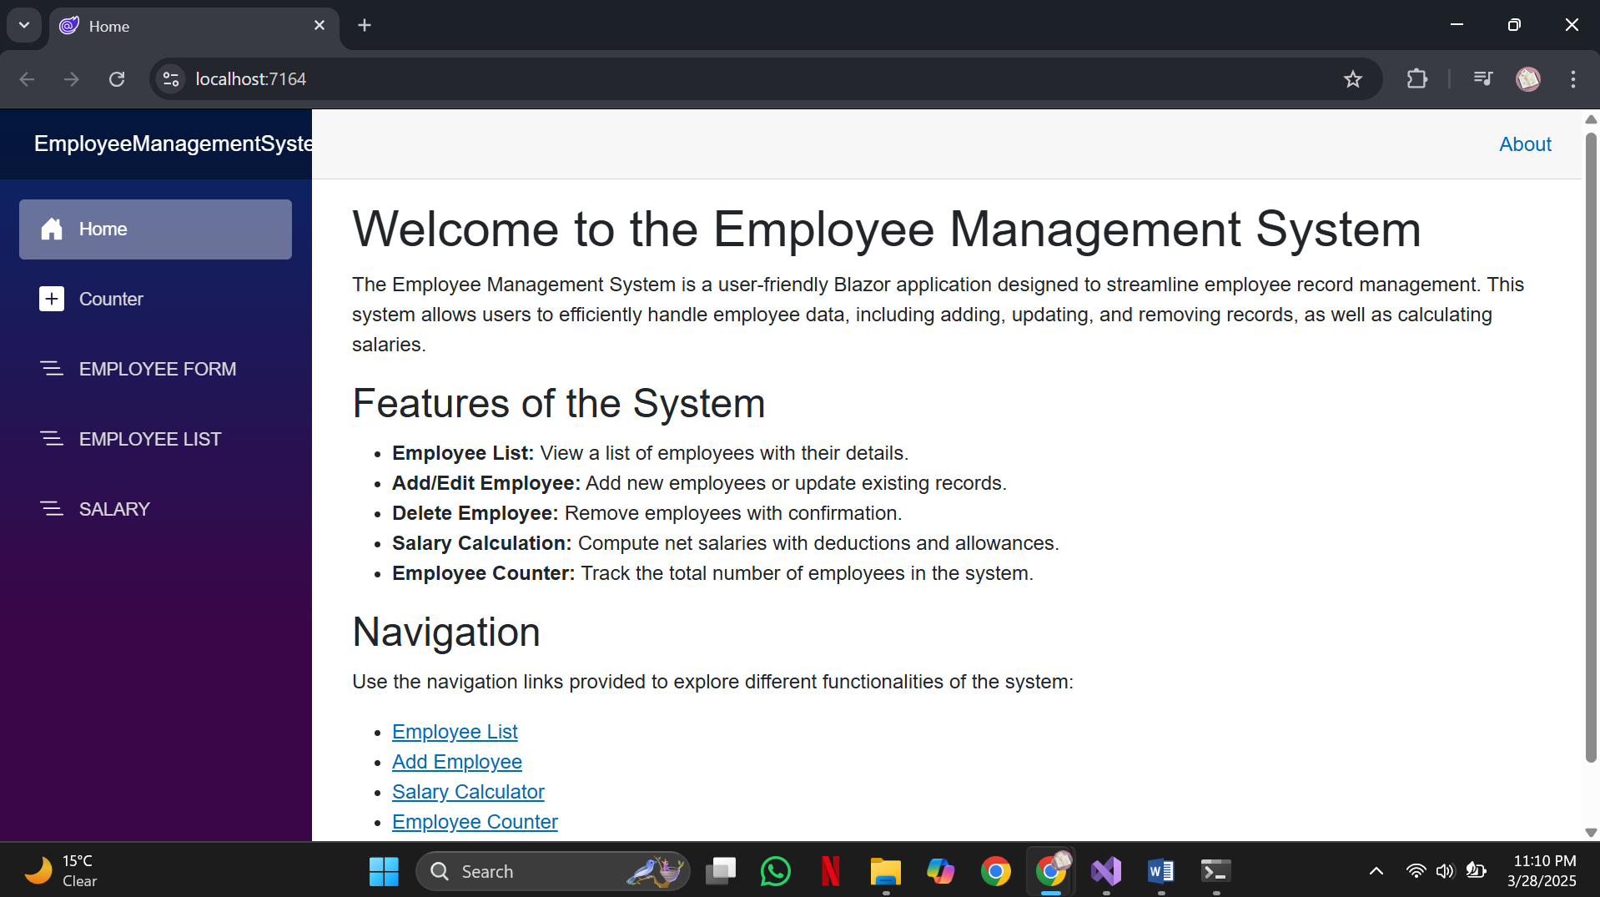
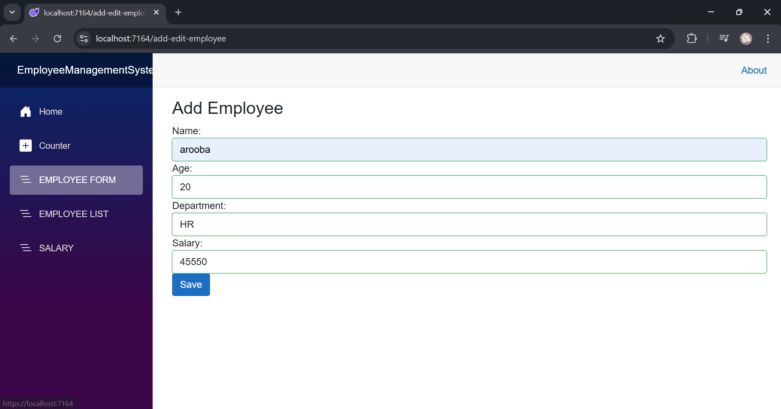
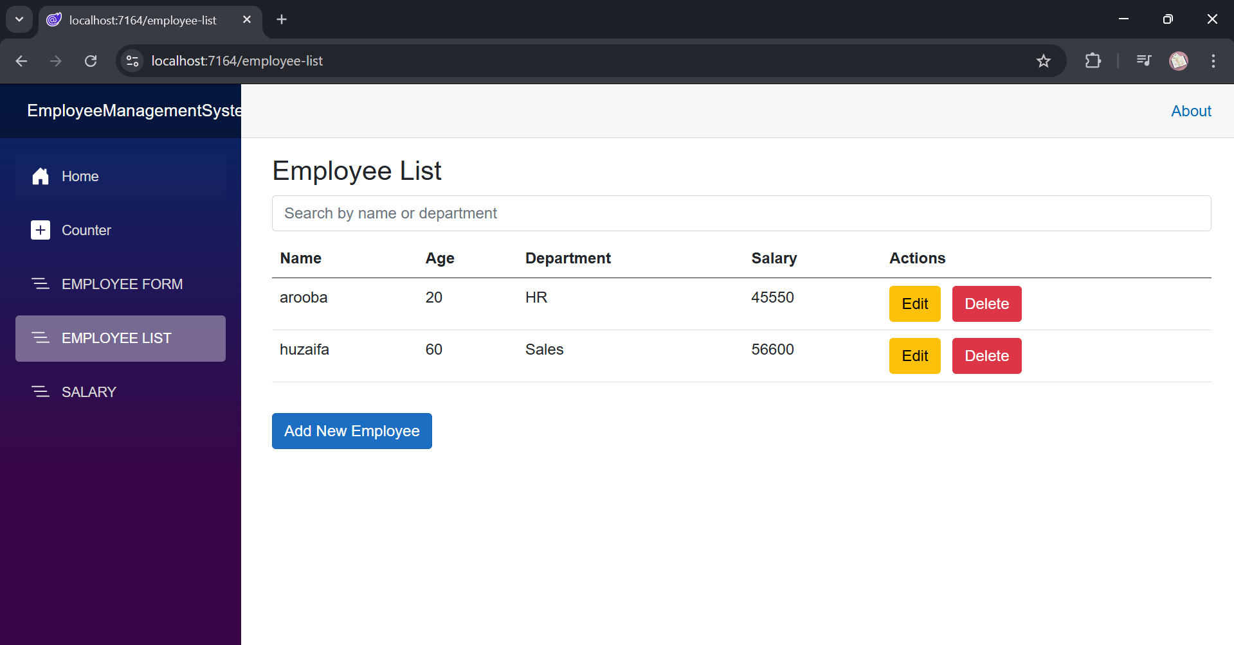

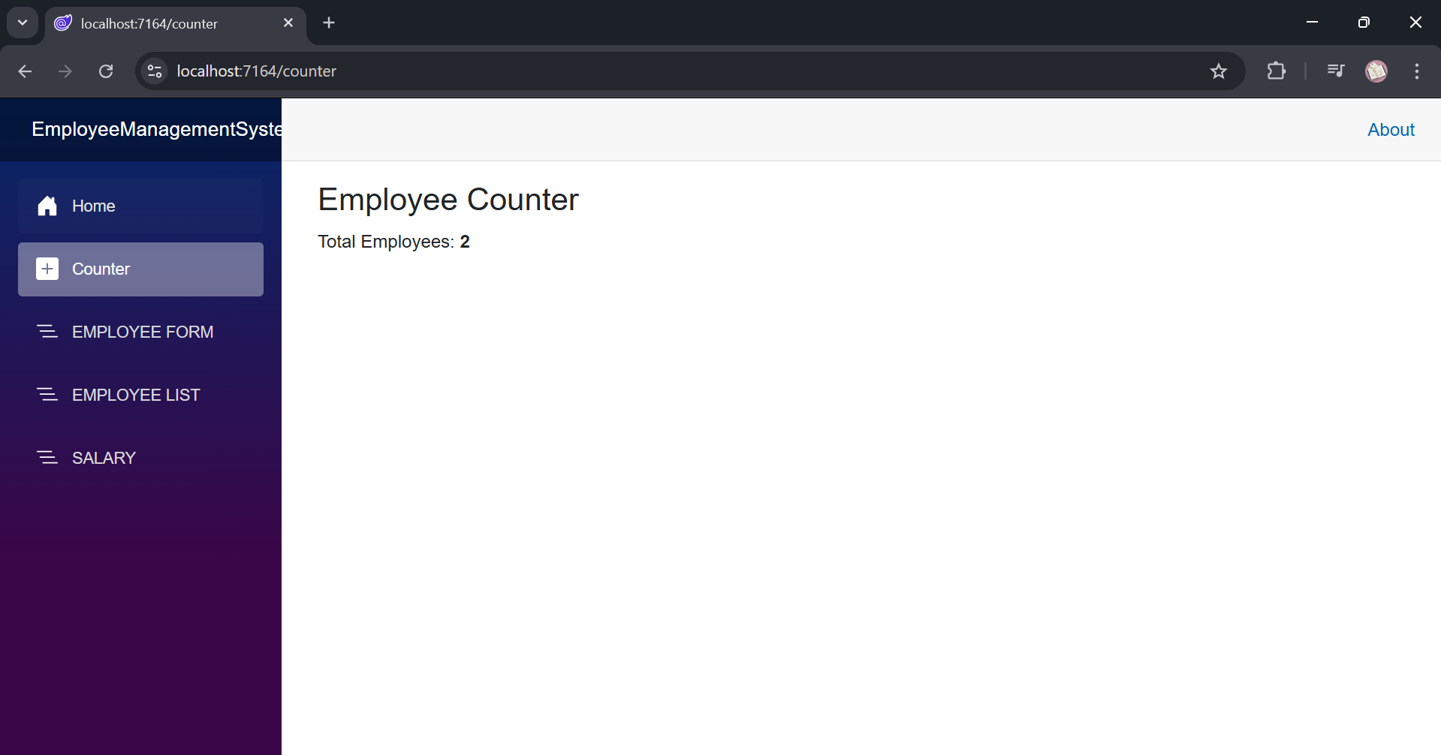

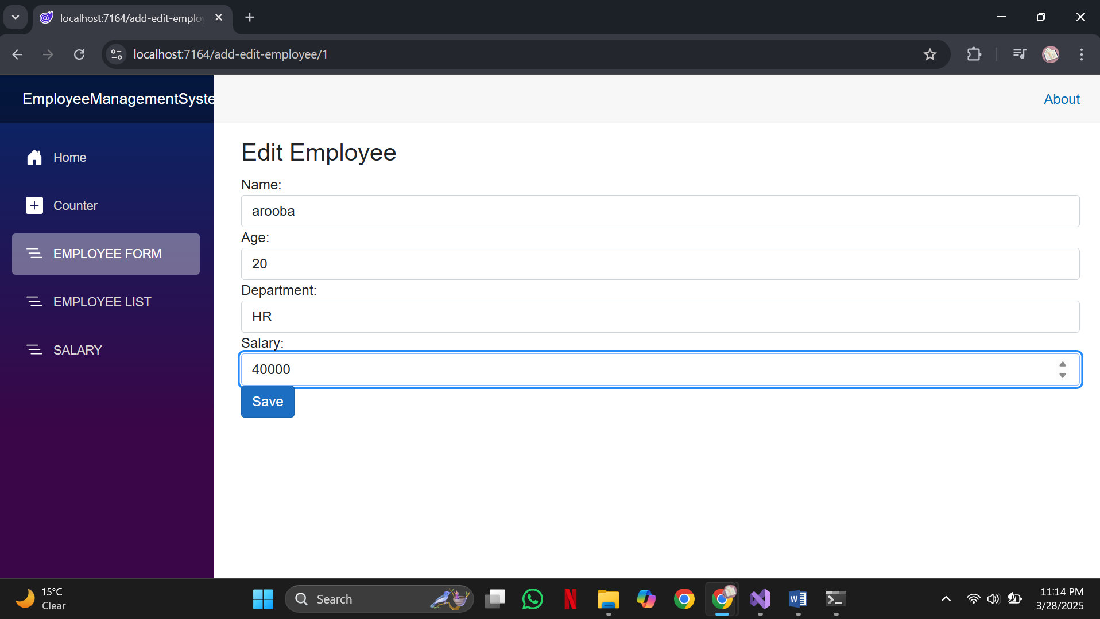
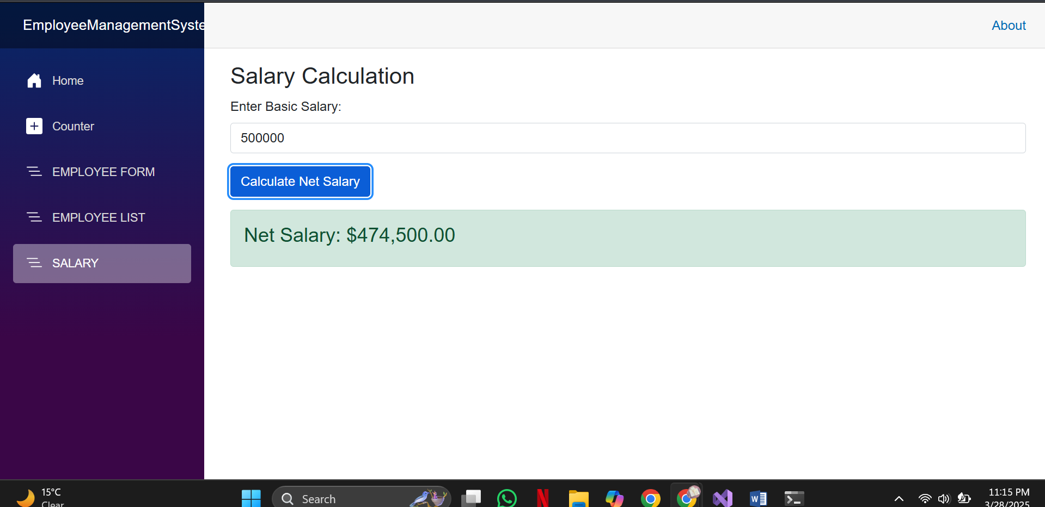

Conclusion
The Employee Management System is a robust and scalable solution for managing employee data. Its interactive features, combined with a clean UI, make it an efficient tool for businesses looking to streamline HR processes. Future enhancements may include user authentication, role-based access control, and integration with external databases.

